Dia 5- ejercicios

Cintia

06/12/2024

Índice

# Quarto

Quarto enables you to weave together content and executable code into a finished document. To learn more about Quarto see <https://quarto.org>.

# Running Code

When you click the **Render** button a document will be generated that includes both content and the output of embedded code. You can embed code like this:

1 + 1

[1] 2

You can add options to executable code like this

[1] 4

The echo: false option disables the printing of code (only output is displayed).

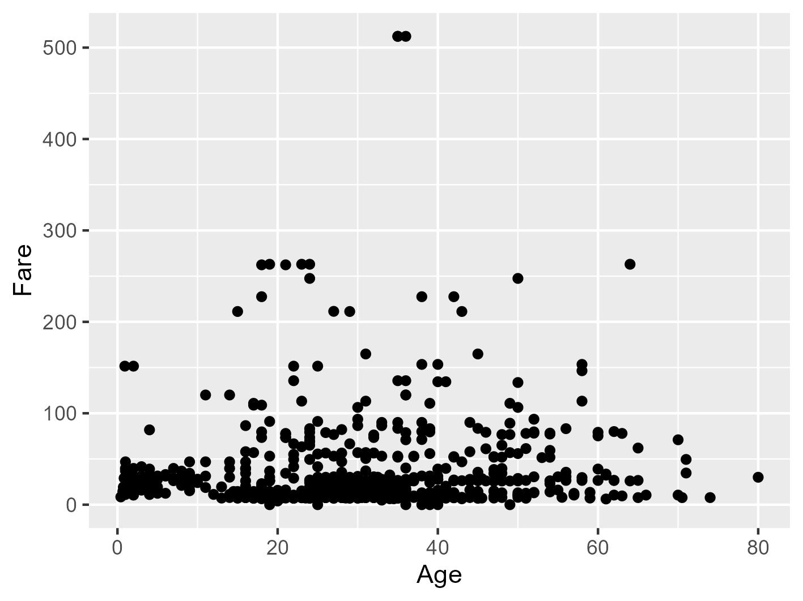

Matano, Palma, and Combes (2019)

Matano, Ricardo P., Elbio D. Palma, and Vincent Combes. 2019. “The Burdwood Bank Circulation.” *Journal of Geophysical Research: Oceans* 124 (10): 6904–26. <https://doi.org/10.1029/2019JC015001>.